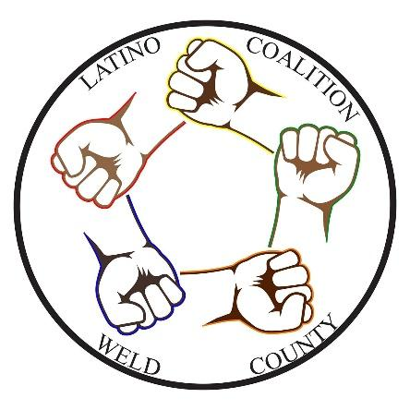
Latino Coalition of Weld County

Board of Director Bios

.

President- Stacy Suniga

Stacy was the owner of a small, local commercial cleaning business that was started in 1992. In 1997, a powerful encounter with a homeless man changed the trajectory of her life. The meeting inspired her to organize other caring citizens to help develop and launch the Room at the Inn program, a 24-hour Greeley shelter and support center for homeless families with children. Once opened, she became the agency's Executive Director, a role that would further engage her into collaborative partnerships with local, state and national programs, and with whom she continued to create effective self-sufficiency programs.
Stacy was recognized for her work in developing the Room at the Inn non-profit agency, by receiving the 2001 Greeley Tribune Unsung Heroes Award and the 2001 United Way Volunteerism Award. She was honored for her success in helping homeless families with the 2001 Group Publishing Community Service Award. In 2010, her peers recognized her outstanding accomplishments and dedication in developing family emergency services and self-sufficiency programs, and for her success in helping Greeley homeless families find long-term, sustainable housing. Stacy received recognition in 2018 by the Hispanic Women of Weld County, who honored her with the Community Leadership Award.
Stacy has served as a commissioner for the City of Greeley Urban Renewal Authority in 2015-2017 and recently served the Greeley community on the Greeley City Council, in the At-large seat. She currently works full-time as an Operations Manager for the Boulder Valley School District. Stacy is proud to be a founding member of the Latino Coalition of Weld County.

Of Counsel- Brandi Lynn Nieto-Pring

Brandi earned her bachelor’s degree from Colorado State University and her Juris Doctor from University of Colorado in Boulder. Brandi has been a resident of northern Colorado since 2005. She has her own law practice and performs contract work for the State of Colorado through the Office of Child Representative; School District 49 and is approved to serve as a Parenting

Coordinator/Decision-Maker in the 8th Judicial District. She also serves as an Assistant Municipal Court Judge for the city of Fort Collins and as an Associate Municipal Judge in the cities of Loveland, Thornton, and Longmont.

Brandi is an active volunteer in the non-profit community and has served her community both on various non-profit boards and as an officer in several legal organizations. She is married and has a three-year-old son. She enjoys exercising, reading, watching documentaries, crafting, and spending time with her family.

Brandi is excited to be working together with other fellow community leaders in northern Colorado to establish the Latino Coalition of Weld County, a non-profit which will serve to foster leadership, representation, and participation by diverse populations at all levels.

